**READ ME AND PROJECT DESCRIPTION**

Project best viewed in **Chrome Version 47 +.**

The project includes all what is desired in the project problem statement. Incorporated all requirements in the project using Java, Servlet, JSP, MySQL.

The project requires tomcat server 7.0 running for it to execute at the same time also the package structure is such that in

\csc5750\src\course –**Inside course package** contains all Java files

\csc5750\WebContent – Contains all jsp files and also project2.sql script file

\csc5750\WebContent\css –All css files

\csc5750\WebContent\js –All js files

\csc5750\WebContent\WEB-INF - web.xml

To test, please import the project in eclipse to run it properly with tomcat running in background.

For Database connectivity have used MySQL, Connection settings:

**DB URL** = jdbc:mysql://localhost:3306/sampledb

**DB Username** = root

**DB Password** = pass1234

Therefore, while testing for successful connection with MYSQL above values should be used for connectivity with MySQL. Sampledb is the database name.

Queries are stored in 2 files:

**project2.sql -** script fileTo run the script file please paste it in C:/ so the url for file will be c:/project2.sql. Script file is run by the java code itself. Through the website.

This file contains queries for table creation**-Users, Posts, Comments** tables.

Insert query to populate Admin with username:Admin and password: 1234

When website is initialized, the sql commands from project2.sql file is read with the help of java files :

**MyJDBCDriver.java –** DB connectivity setting are stored/retrieved from this class

**SQLReader.java -** Class for reading the sql scriptfrom project2.sql

**mainLoader.java –** Class for executing the sql script **read by SQLReader** from project2.sql and executing the SQL commands.

**TextBank.java –** Class contains all possible queries which required extra data such as following:

**Select statements** for Posts, comments, Users tables.

**Insert statements data** into Users, Posts, Comments tables.

**Delete statements** for deletion of Posts ,Comments

**User.java, Post.java, Comment.java**

For **User, posts and comments tables** have made java classes namely **User.java, Post.java, Comment.java.** These are pojo classes used to store objects in java objects when the details are retrieved form the Database .

**Home Servlet (Home.java and home.jsp)**

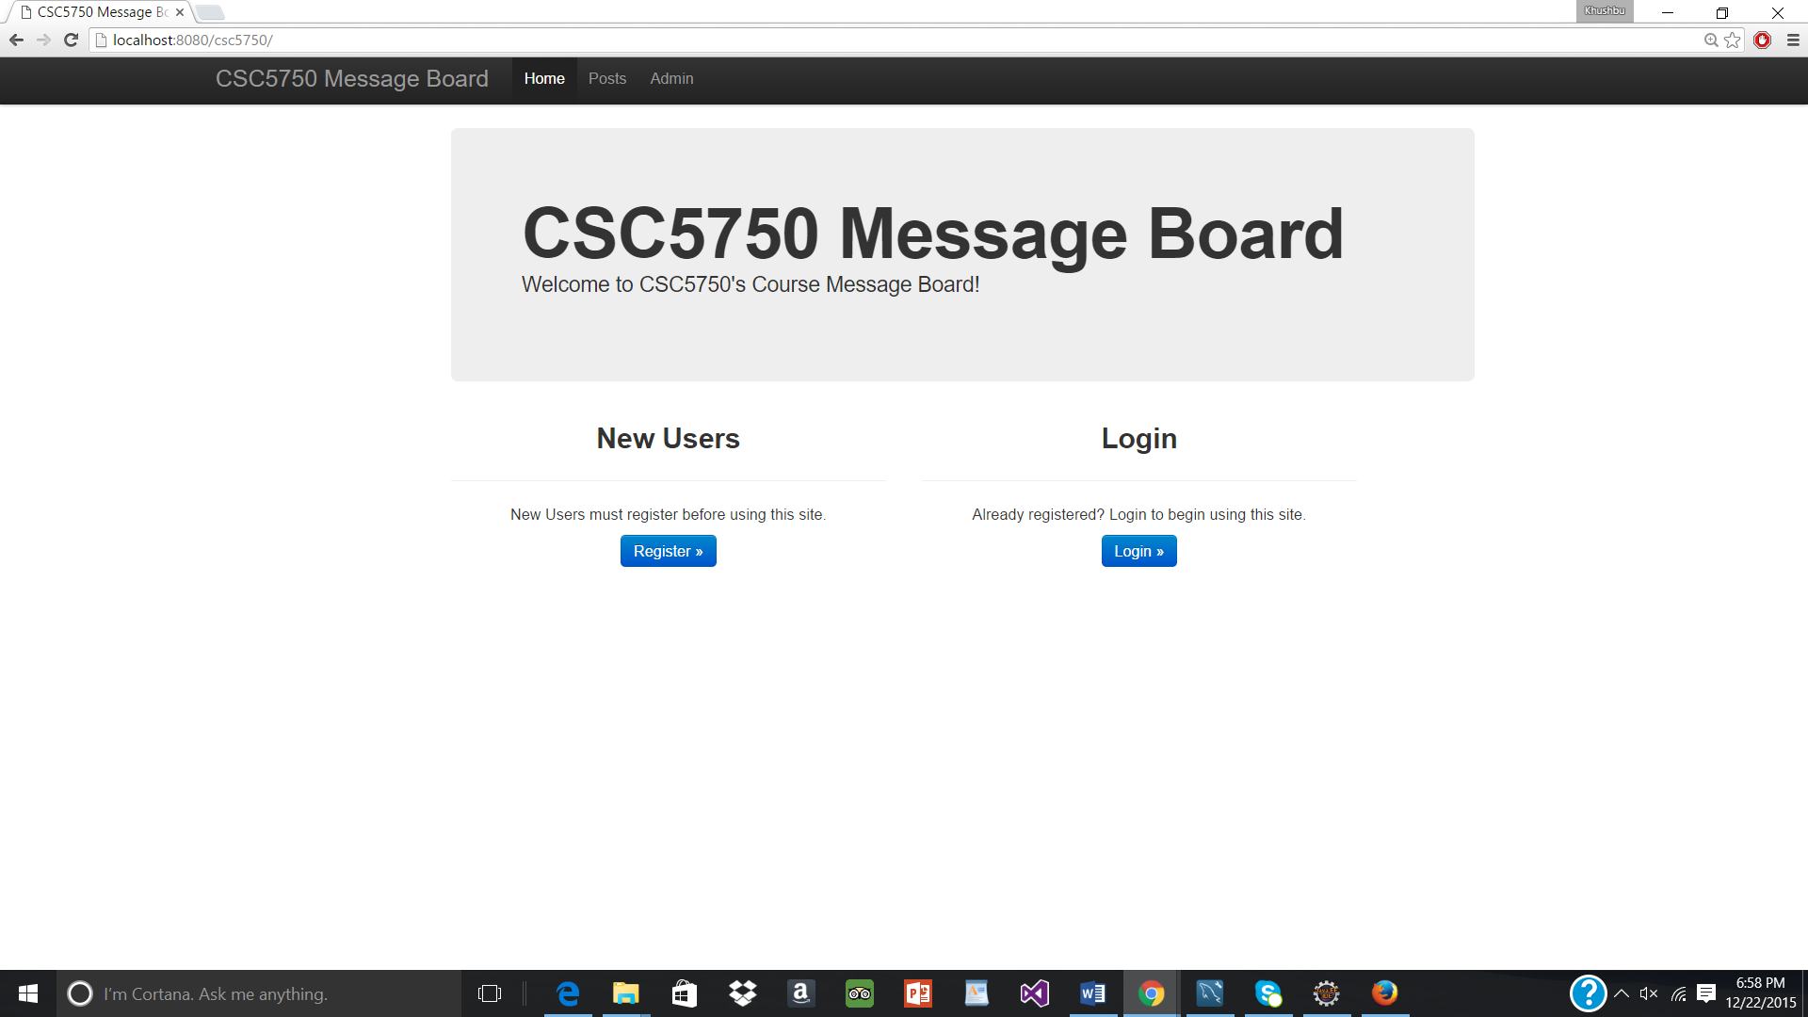

Available on [**http://localhost:8080/csc5750/**](http://localhost:8080/csc5750/) on the browser

Mapped to /csc5750/fy6259/project2/Home in the servlet

**Home servlet** redirects to Register servlet or Login servlet based on the button clicked.

On the click of Register the Register servlet is called.

On the click of Login the Login servlet is called.

On the click on either of the buttons, the tables get created in the backend, this is is done by reading the sql script file named project2.sql done by java.

**Home.jsp –** Contains the UI in jsp page.

**Register Servlet (Register.java and registerpage.jsp)**

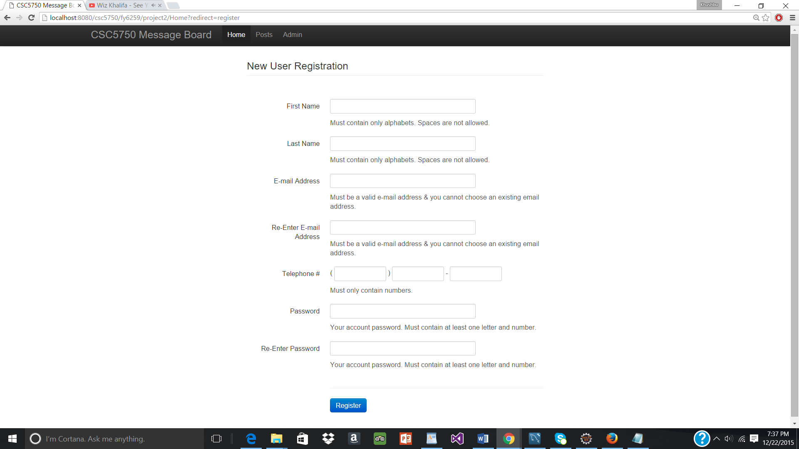

All form data are submitted back to the Register Servlet, and validated.

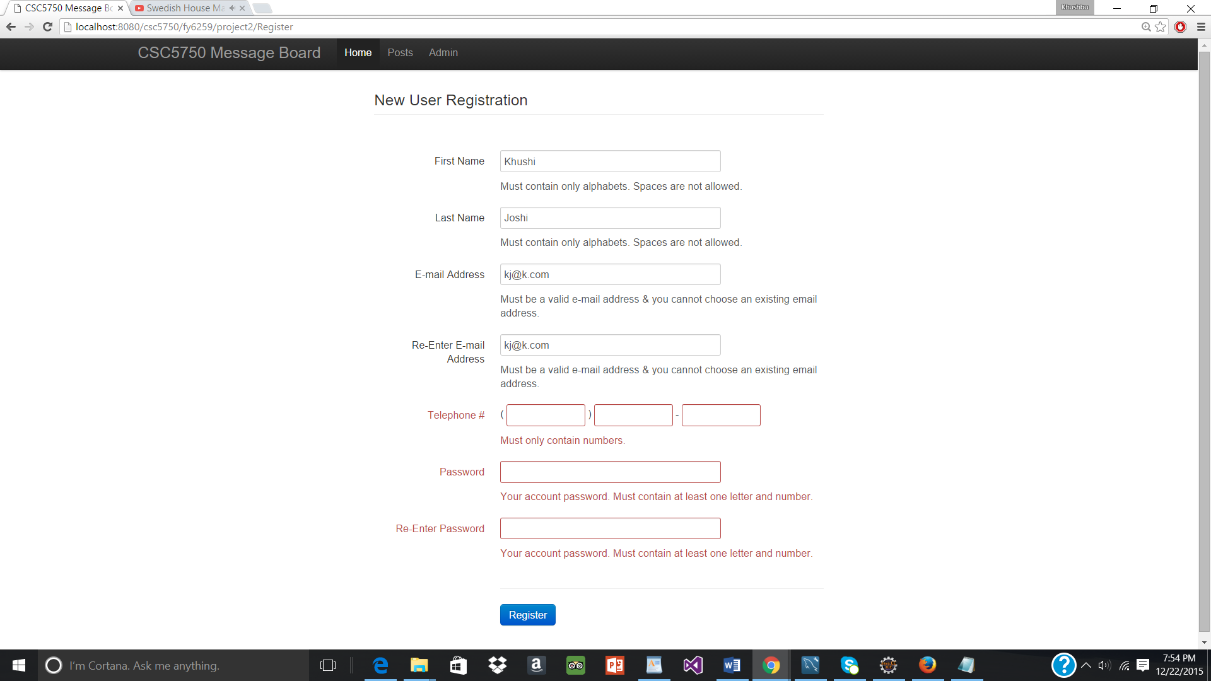The Register Servlet should ensure that all fields are populated with the correct type of data. Checks are done in Register.java servlet itself

**For first name, last name** - check is made to ensure it doesn’t contain any empty space & shouldn’t contain digits. If fields do now fall in this criteria then error css class is added and registerpage.jsp is redisplayed.

**For both passwords**- check is made that both password should contain a digit and an alphabet as well as both password and confirm password should match with each-other. If passowrords do not follow this criteria then error css class is added and registerpage.jsp is redisplayed.

**For telephone** – made sure all are digits else error css class is added and registerpage.jsp is redisplayed.

**For email-** Both email ids should match and also both should be in valid email format. If email format are not valid/blank or if a user with same email already exists then also the error css is added to email fields and page is redirected to registerpage.jsp.

When errors are encountered (including blank form fields), re-display registerpage.jsp the form adding the .error CSS class to control-group that contains a form element with an error.

registerpage.jsp contains UI and values/response rendered from Register.java servlets are used here to display either error or in case of success redirect to Login.java

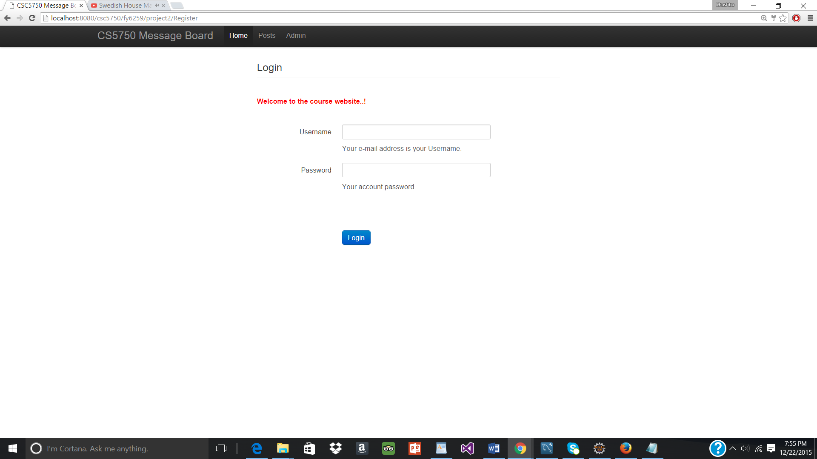

If all values are valid then the new user is added with that credentials and user is redirected to Login page with a welcome message. Insert statement is read from TextBank.java and then values from the page are appended to query and values inserted into DB

**Login Servlet (login.java, login.jsp)**

Once user enters credentails, checks whether those details are correct from the values stored in the DB.Error message as below is shown in case of incorrect credentails.

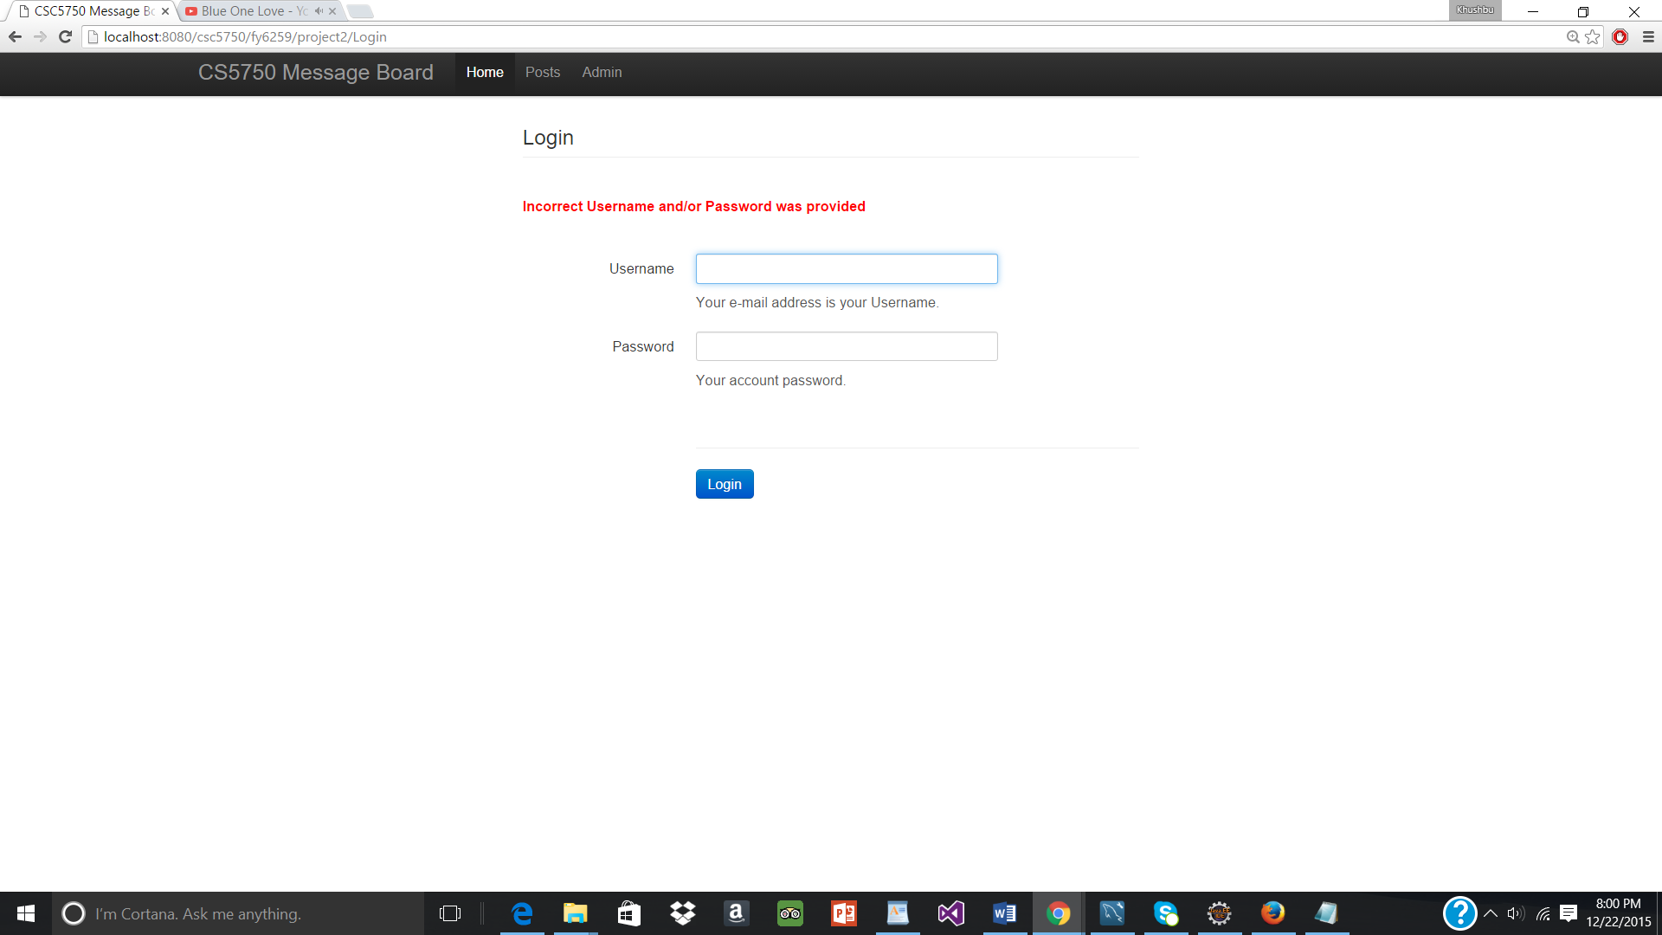

The details are checked against values stored in database. So select statement is used to search user with the entered credentials. Query taken from TextBank.java file. On correct details the user is given access and Posts servlet is called on correct credentials, else the error message is displayed. On correct credentials the user is adding session.

If already some other user is logged in and again user tries to login then error message is displayed as below

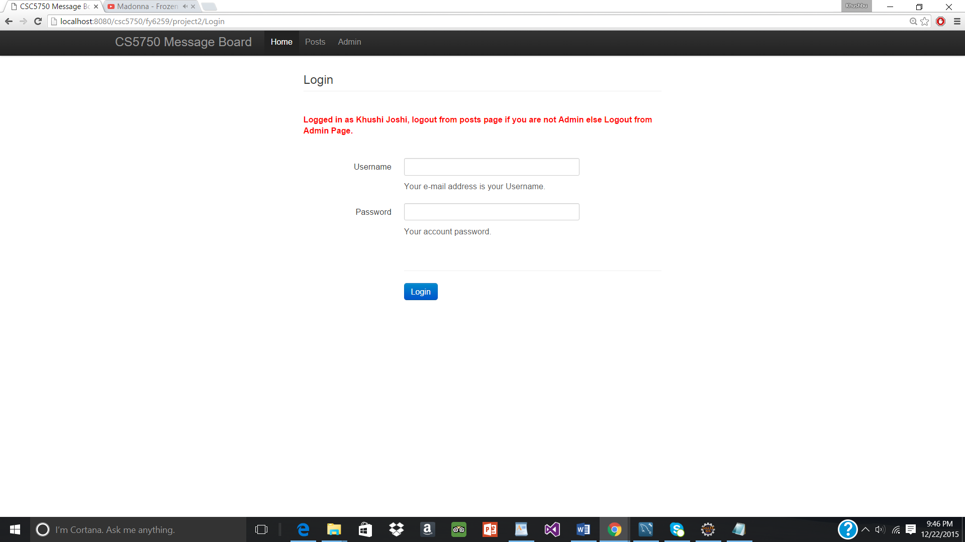

Also, for action parameter logout, the user will be logged out if already logged in.

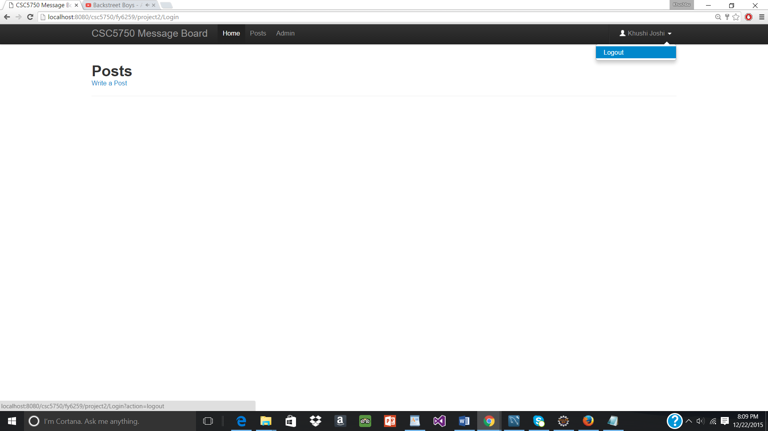

**Posts Servlet – Posts.java, posts.jsp**

In Posts servlet, the values are retried from database to get all the posts from the back-end. This servlet fetches all the posts and also commented related to the post in orderly fashion and this details are displayed in the Posts.jsp.

Posts.java uses TextBank.java to create sql query and retrieve the Posts and comments.Posts.java contains code that is responsible to add posts, add comments and also delete posts/comments.

When no posts are there user is prompted to write post.

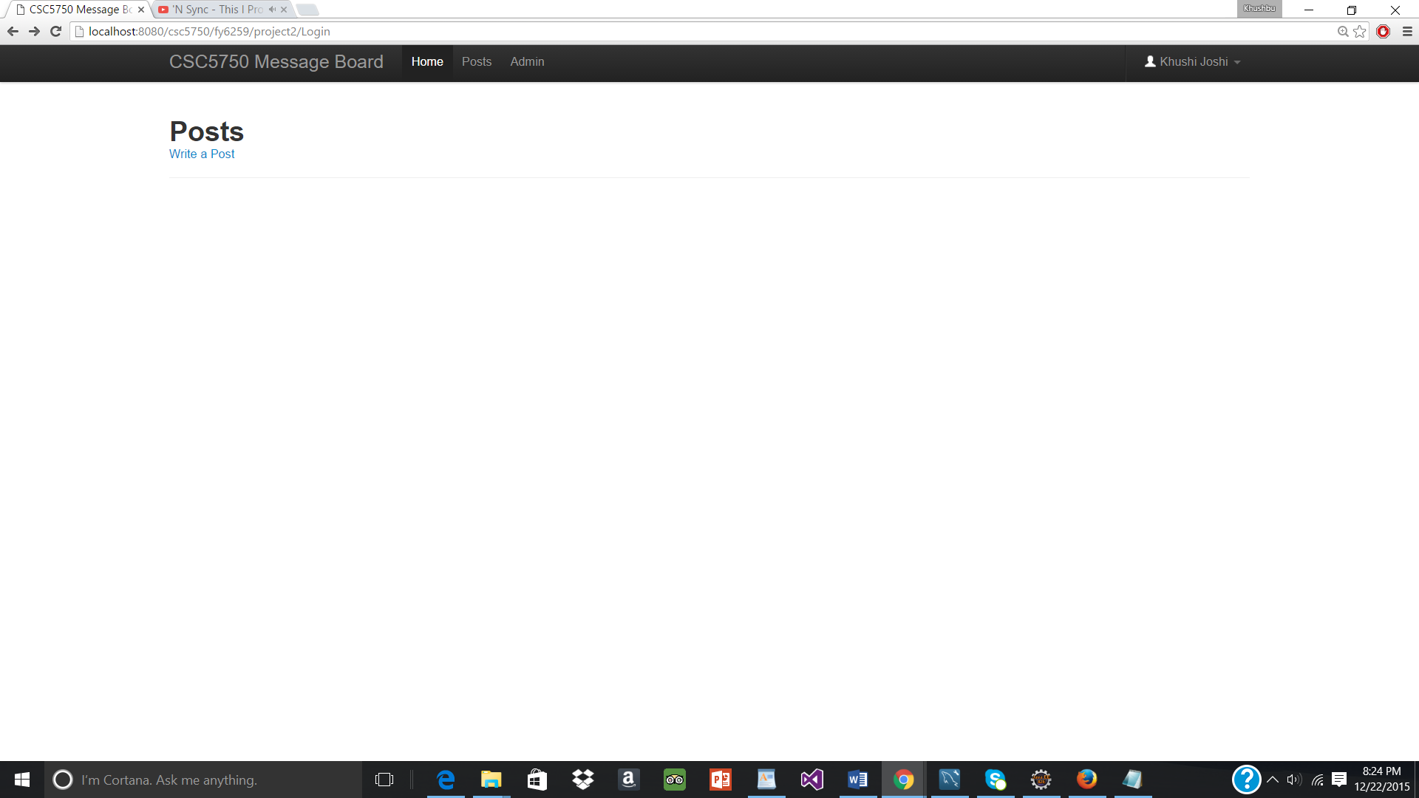

**NewPost.jsp**

For Adding new post on clicking ‘Write a Post’ link the NewPost.jsp is opened and user has to enter post title and content for the post. If any value is blank user is alerted of the same.

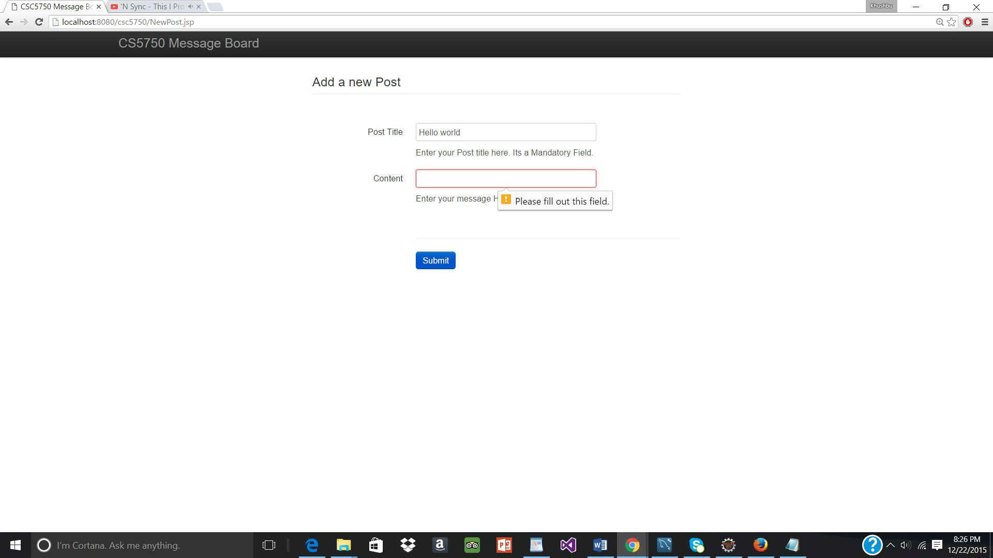

If all values are entered corrected the Posts.java servlet is called where the new post is added into the Database. Then the user is redirected to Posts.jsp page where the added post are shown.

**Posts.jsp**

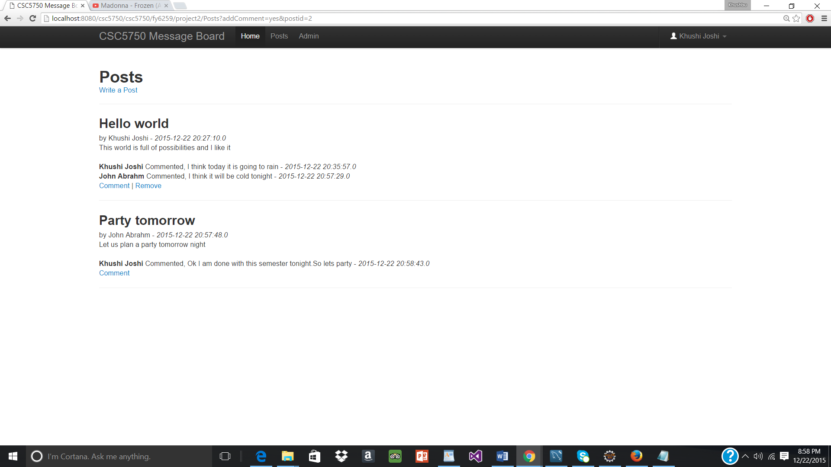

Contains the posts made by all he users in the database along with the comments in orderly fashion. The posts only by logged in user will appear with remove link. User can normally comment on any posts.

Lists all the comments Posts by all users. Here the logged in user can remove/add posts posted by him/her. Post added by others can’t be controlled by logged in user. But can only be done by admin.

**Comment.jsp and Comment.java**

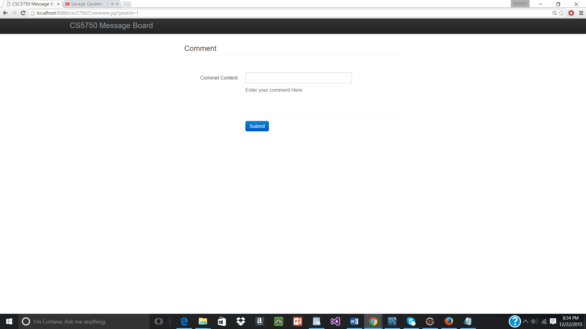

Comments.jsp contains UI for user to enter a comment. If no data entered then user is redirected to posts page else if comment entered then it gets displayed on the posts page.

**NotAnAdminView (NotAnAdmin.jsp page)**

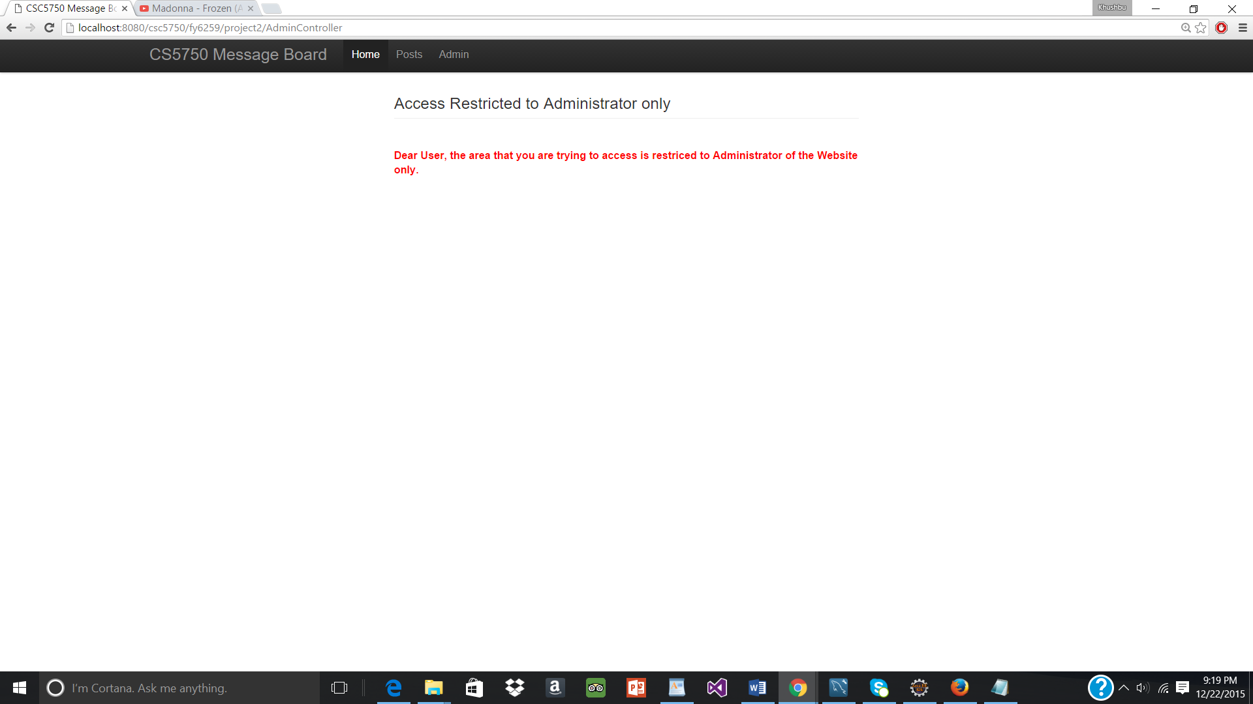

For non admin users, clicking on Admin link in the header will lead them to NotAnAdmin.jsp page Here it informs user that this page is only accessible by administrators.

**Admin Controller – servlet and AdminView.jsp**

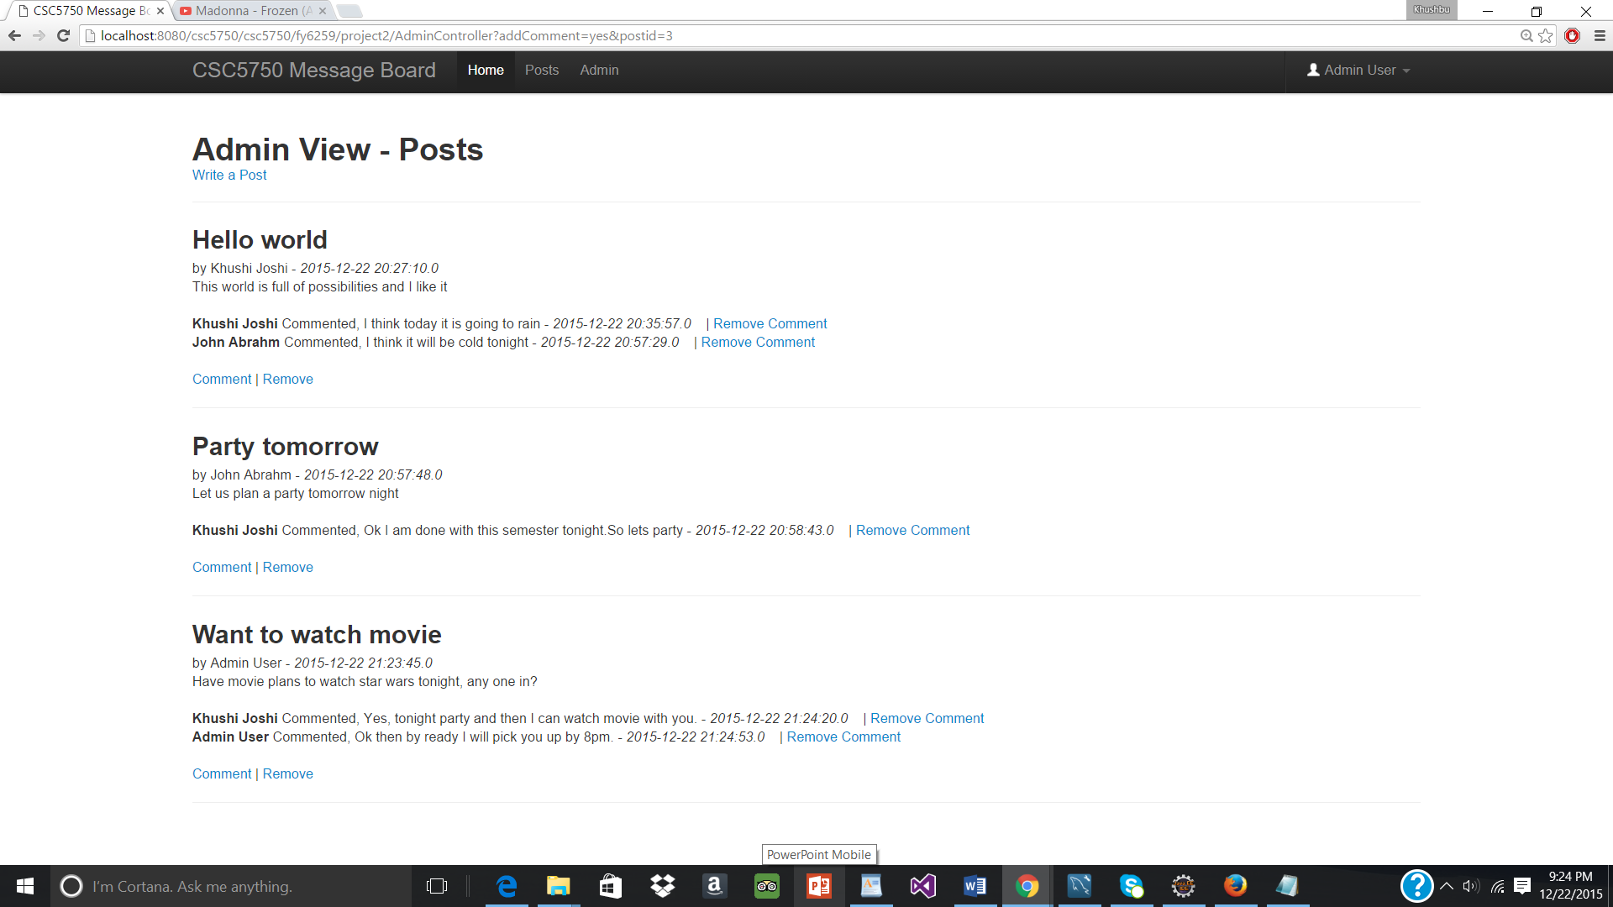

AdminController.java allows admin to see all the posts/comments by all users in the DB. At the same time the Admin can remove a particular post or a particular comment individually depending on this choice. This view is possible if and only if user is loged in as Admin with the credentials Username - Admin , password – 1234. Anyone else cannot see this view.

Clicking on remove link for a post will delete the entire post will comments associated with that post. Clicking on Remove for a particular comment will delete that comment only.

At the same time Admin can also add new comments & posts. On removal user is redirected to this Admin view page again with comment/post removed.

After removal of comment of Khuhi Joshi, in the 1st post.

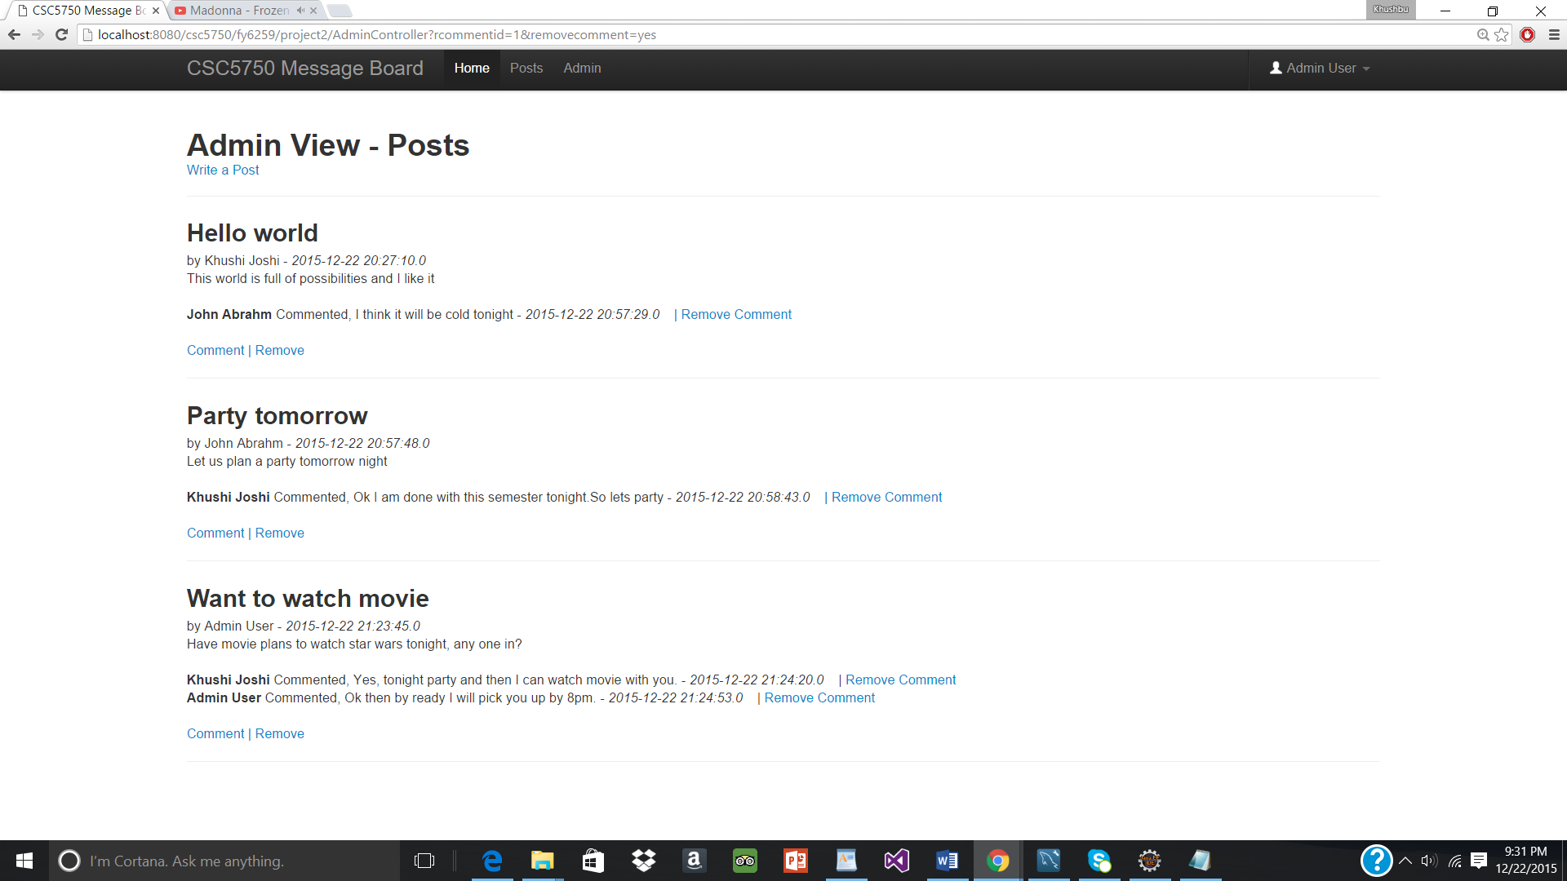

After removal of the Post by John Abhram. The post as well as associated comments are all deleted.

